This marketing toolkit is for Seattle Employee Transportation Coordinators (ETCs) and representatives at Seattle businesses to promote the Seattle Commute Survey. The survey is live starting on Monday, October 3, 2022, and will close on Friday, November 18, 2022.
The 2022 Seattle Commute Survey and Mode Split Study is supported by the University of Washington Mobility Innovation Center and Challenge Seattle, in partnership with the Seattle Department of Transportation and Washington State Department of Transportation.
What is included in this Marketing & Communications Toolkit?
Contents
Survey Link & QR Code
Email Templates
IT Department (4 weeks before survey start date)
Managers and Supervisors (1 week before survey start date)
Employee Communication Survey is Coming (1 week before state date; send after Managers/Supervisors)
Employee Communication Survey is Live (Survey Start Date, October 3)
Employee Communication Survey Reminder (1 week before close, October 24)
Thank you!
Digital Banners
Commute Survey Coming!
Why a Commute Survey?
Ready Set Survey!
Seattle Commute Survey
Your Commute Matters
Last Chance!
Thank you!
Print Materials
Poster – 11 x 17in Portrait
Letter – 8.5 x 11in Portrait
Card – 5 x 7in Portrait

Survey Link & QR Code
https://bit.ly/seattle-commute-survey
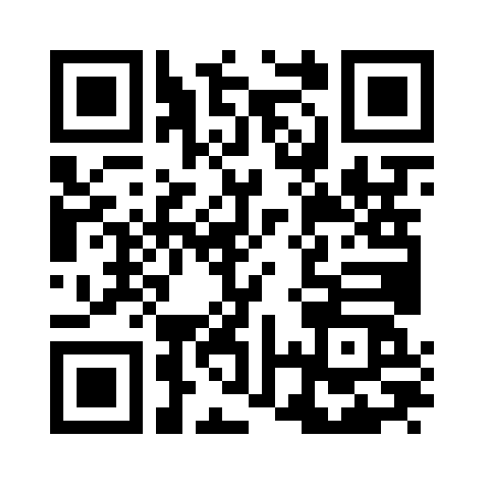

Email Templates
Please use these email templates to communicate the survey to the necessary people.

IT Department (4 weeks before survey start date)
Suggested Subject: Save the Date: Seattle Commute Survey Coming October 2022
We have a <<state-mandated>> transportation survey starting on Monday, October 3, 2022. Employees will complete the survey online using Qualtrics, a tool provided by the University of Washington. On Monday, October 3, 2022, we will send a hyperlink and instructions to employees. Preview the questions online.
The survey tool is entirely web-based and requires individuals to have access to the internet or a smartphone to complete it. There are no other technical requirements. Data privacy and storage standards are consistent with the City of Seattle Privacy Policy and the UW Institutional Research Board. We will not need to store data or operate the system on our servers, and nothing gets installed on our system.
Thank you,
<<Name>>, Transportation Coordinator
<<Email>> | <<Phone>>

Managers and Supervisors (1 week before survey start date)
Suggested Subject: Action Requested: Seattle Commute Survey Coming October 2022
State law requires <<Company Name>> to survey our employees regarding their commuting habits. State and local governments use this data to make decisions about transportation investments and improvements. Internally, we use the survey results to determine possible updates to our commuter benefit packages.
This coming Monday, October 3, 2022, an email will be sent to all employees asking them to complete the survey. The email will contain a link to the website where employees will complete the survey. The survey typically takes less than five minutes to complete.
We are one of over 1,000 employers in Washington State participating in the survey. Local ordinances require a significant data response or at least a 50 percent response rate. It’s important that everyone participates, not just employees who use alternatives to driving alone to work, so we are asking for your help in reminding your team(s) to complete this required survey.
If you have any questions, please contact me directly.
Thank you,
<<Name>>, Transportation Coordinator
<<Email>> | <<Phone>>

Employee Communication Survey is Coming (1 week before state date; send after Managers/Supervisors)
Suggested Subject: Save the Date: Seattle Commute Survey Coming October 3
The Seattle Commute Survey is coming up next Monday, October 3, 2022. It will take you about 5 minutes to complete. All employees should complete the survey, not just those who use alternatives to driving alone to work.
We are completing the survey online at https://bit.ly/seattle-commute-survey. We will send an email on Monday announcing the survey and sharing the live link.
This statewide survey gathers information about how over 500,000 employees in Washington State commute to work. Having accurate data about commuting is important to state and local governments in deciding how to invest our tax dollars in transportation. We will also use your information in-house to determine possible adjustments to your commuter benefits package.
If you have any questions, please contact <<Name>> at <<Email>> or <<Phone>>.
Kindly,
<<Name>>, Transportation Coordinator
<<Email>> | <<Phone>>
<<HRO Name>>, CEO or Highest-Ranking Official’s Title
<<Email>> | <<Phone>>

Employee Communication Survey is Live (Survey Start Date, October 3)
Suggested Subject: Immediate Action Requested: Take the Seattle Commute Survey
The Seattle Commute Survey will take you about 5 minutes to complete. All employees should complete the survey, not just those who use alternatives to driving alone to work.
Complete the survey online: https://bit.ly/seattle-commute-survey
This statewide survey gathers information about how over 500,000 employees in Washington State commute to work. Having accurate data about commuting is important to state and local governments in deciding how to invest our tax dollars in transportation. We will also use your information in-house to determine possible adjustments to your commuter benefits package.
If you have any questions, please contact <<Name>> at <<Email>> or <<Phone>>.
<<Closing Option 1: Thank you for completing your survey.>>
<<Closing Option 2: To make this survey more fun, we are holding a special prize drawing for <<insert prize>> from the pool of employees who complete the survey! Don’t wait and miss out on the prize!
Kindly,
<<Name>>, Transportation Coordinator
<<Email>> | <<Phone>>
<<HRO Name>>, CEO or Highest-Ranking Official’s Title
<<Email>> | <<Phone>>

Employee Communication Survey Reminder (1 week before close, October 24)
Suggested Subject: Final Reminder: Take the Seattle Commute Survey
The deadline for the Seattle Commute Survey is rapidly approaching. You have until November 18 to complete the survey. We are required to achieve a significant data response or 50% response rate. Your participation is critical in not only meeting the state mandate but also for upcoming decisions on transportation investment and our company’s commuter benefits.
Complete the survey online: https://bit.ly/seattle-commute-survey. It only takes about 5 minutes to complete.
If you need help or have additional questions, you can reach me at <<Email>> or <<Phone>>.
Kindly,
<<Name>>, Transportation Coordinator
<<Email>> | <<Phone>>

Thank you!
Suggested Subject: Thank you for completing the Seattle Commute Survey!
Thank you for your participation in the Seattle Commute Survey! Your input will help guide transit service, capital investment, and public policy now and into the future.
The survey is now closed. Commute Seattle and the University of Washington Mobility Innovation Center are cleaning, processing, analyzing, and summarizing the survey data. Top-line results will be available by January 2023 and our company report by March 2023. If you have any questions, please contact <<Name>> at <<Email>> or <<Phone>>.
Commute Seattle is here to help with our transportation needs! Email info@commuteseattle.com to learn more about climate-friendly travel options!
Kindly,
<<Name>>, Transportation Coordinator
<<Email>> | <<Phone>>

This page is intentionally left blank.

Digital Banners
Right click the photo(s) below to “Save as Picture” to your computer.

Commute Survey Coming!
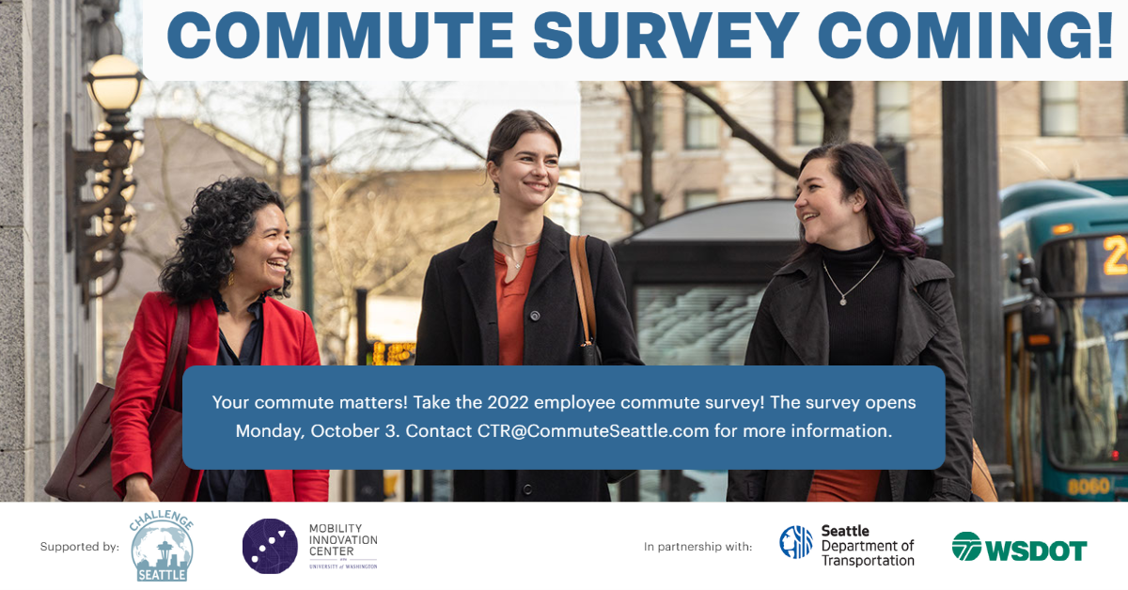

Why a Commute Survey?
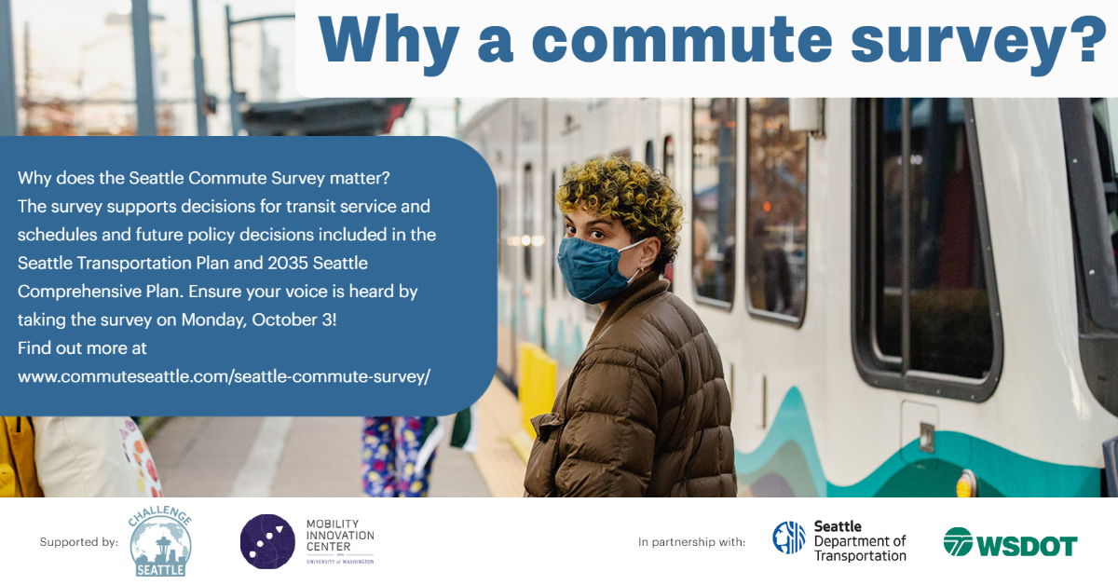

Ready Set Survey!
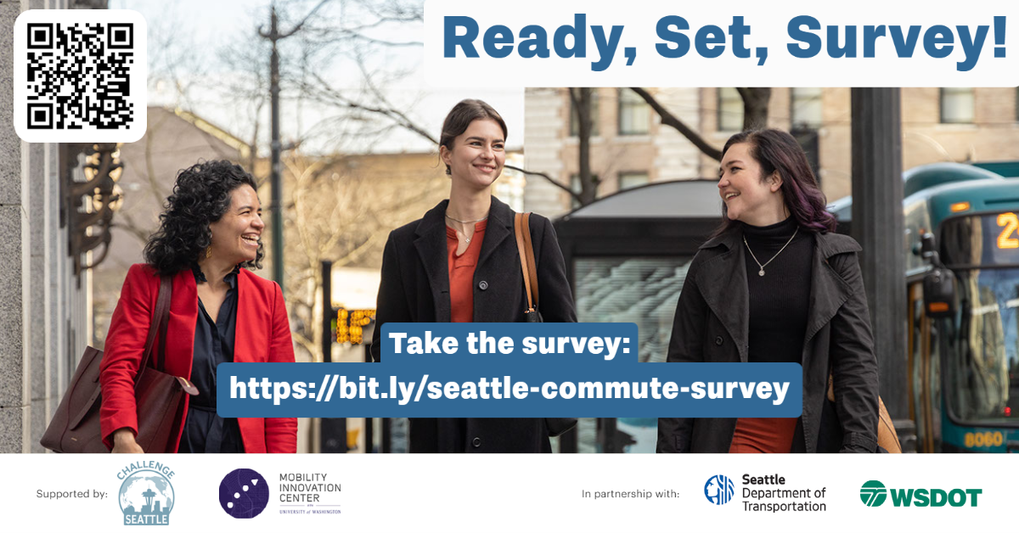

Seattle Commute Survey
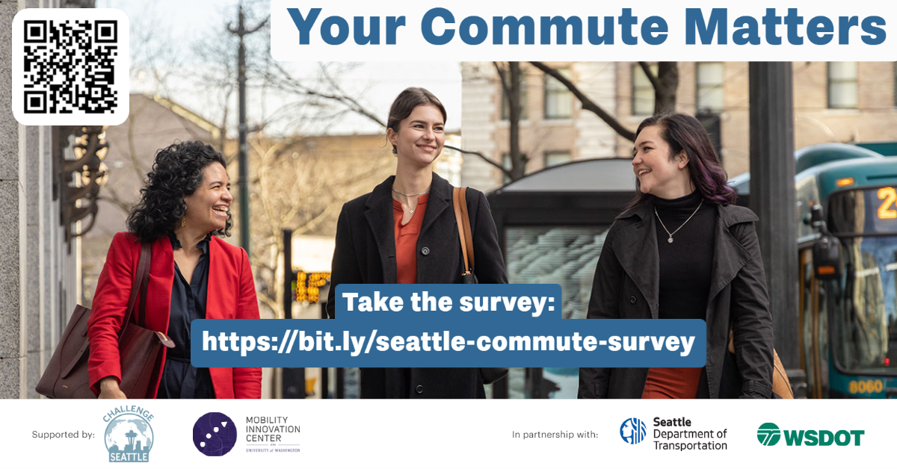

Your Commute Matters
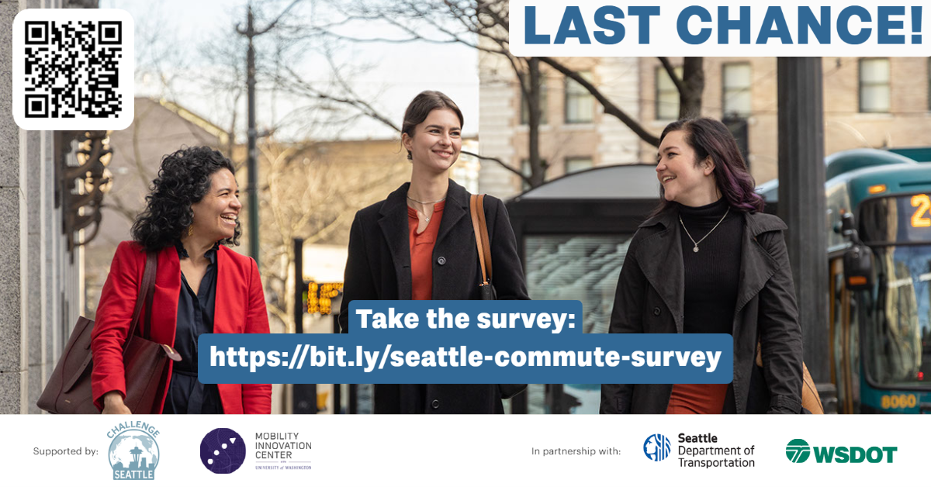

Last Chance!

Thank you!
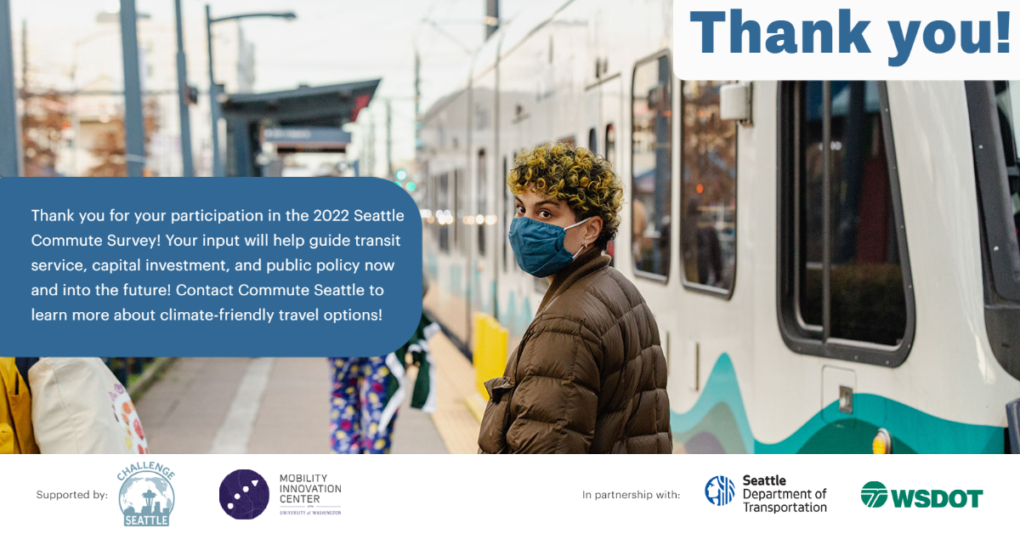

This page is intentionally left blank.

Print Materials
Click the links below to download a PDF of the print materials.

Poster – 11 x 17in Portrait
https://downtownseattle.sharepoint.com/:b:/s/CommuteSeattle/EfCXTgBKb3lLlExXjPILsOwBAF0xmmbKEL2KmAidmJ-0Bg?e=cL9oJg

Letter – 8.5 x 11in Portrait
https://downtownseattle.sharepoint.com/:b:/s/CommuteSeattle/EWoEMXG_VSBNuN-gUHh5pDsBrBGzqCxojNtagWJg2lQ72A?e=s2lOzq

Card – 5 x 7in Portrait
https://downtownseattle.sharepoint.com/:b:/s/CommuteSeattle/Ec-tvgKB0exDiWjxuX6iPoEBD984amWKxnvDkYWiGLo4eg?e=uJ0xW8

