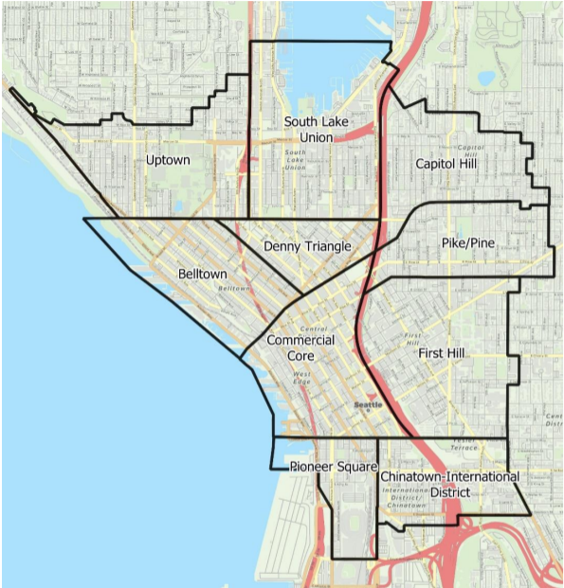
  - Request for Proposals for Seattle Center City Multi-Modal Graphic Design

Background
Commute Seattle is a nonprofit Transportation Management Association founded in 2004. Our mission is to foster mobility partnerships to keep Seattle moving and thriving for all. We are a non-profit supported by an alliance between the Downtown Seattle Association, King County Metro, Sound Transit, and the City of Seattle.
Commute Seattle is a fast-paced organization focused on partnering with employers and institutions to implement sustainable transportation options and trip reduction strategies that positively change commute behavior, improve quality of life, and support economic and environmental goals.
1: Seattle Center City Mode Split Study Map

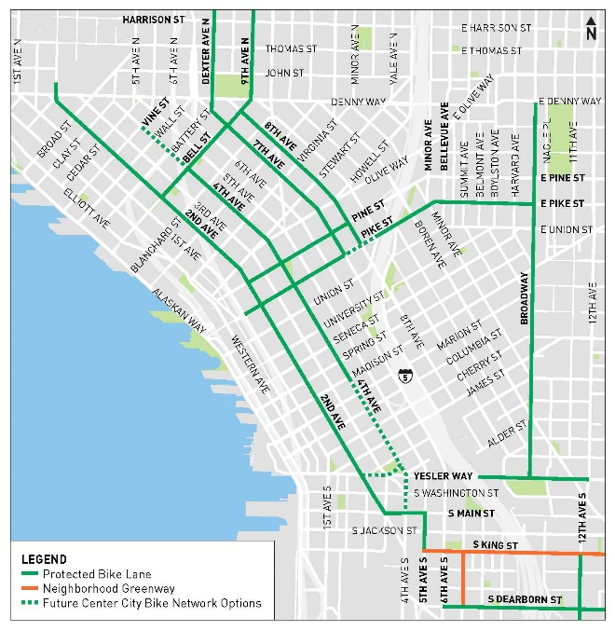
Project Overview
As Seattle emerges from the pandemic, more people are making trips to serve their daily needs. According to the Levy to Move Seattle Dashboard and The Seattle Times Traffic Lab, since the beginning of 2020 SDOT has built almost 7 miles of protected bicycle lanes, nearly 30 blocks of new sidewalk, and also repaired over 56,158 square feet of sidewalks. Many people are unaware of the new pathways for people walking and biking. The purpose of this project is to develop a fun and accessible medium that educates people on a new bicycle and walking infrastructure in Seattle’s Center City.
2: SDOT Center City Bike Map

Project Goals
Commute Seattle is seeking graphic design services to develop and execute a multi-modal medium articulating new bicycle and pedestrian facilities in Seattle’s Center City.
The primary goal of the product is to showcase new bicycle and pedestrian facilities and highlight major access points and/or landmarks in Seattle’s center city in a fun and accessible format.
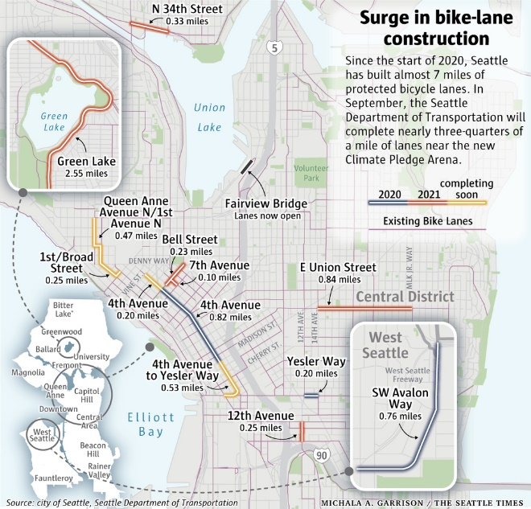
A secondary goal for this project is for the product be developed now, and updated in the future, as new capital investments are made. The award will be made to a responsive and responsible firm based on the best value and professional capability.
3: The Seattle Times Surge in Bike Lane Construction
The selected firm will be responsible for the development and production of a comprehensive and cost-effective graphic design product.

Project Scope
Seattle’s Center City to be defined as the neighborhoods including Commercial Core, Belltown, Denny Triangle, Pioneer Square, Chinatown-International District, First Hill, Pike/Pine, Capitol Hill, South Lake Union and Uptown.
The desired product is to be available via web and print. The desired product is to be interactive where possible. The desired product is to meet the Commute Seattle brand standards. The desired product is to be designed in plain language, translated in Seattle’s Top Tier Languages, and with diverse and inclusive photography. The desired product includes all raw and packaged files. Commute Seattle retains ownership of all product files.

Anticipated Selection Schedule
The Request for Proposal timeline is as follows:
- Request for RFP: August 27, 2021
- Deadline for Bidders to Submit Questions: September 7, 2021
- Commute Seattle Responds to Bidder Questions: September 7, 2021
- Selection of Top bidders / Notification to Unsuccessful Bidders: September 13, 2021
- Start of Negotiation: September 14, 2021
- Contract Award / Notification to Unsuccessful Bidders: September 20, 2021

Time and Place of Submission of Proposals
The RFP will be posted on our website, www.CommuteSeattle.com, and can be downloaded from there direction as of August 27, 2021.
Respondents to this RFP must submit their proposal by PDF. Responses must be received no later than September 10, 2021. Responses should be clearly marker “RFP-Commute Seattle Graphic Design Services” and emailed to the contact person listed below.

Timeline
Commute Seattle needs the project completed by November 1, 2021.

Elements of Proposal
A submission must, at minimum, include the following elements:
- Description of the firm that includes a general overview, names and credentials of creative team, number of full-time employees. Commute Seattle prioritizes Women-, LGTBQI+, and BIPOC-Owned small businesses.
- Description of the expertise of the firm working with vulnerable and diverse communities for at least 3 years.
- A one-page narrative outlining the firm’s strengths and distinguishing skills or capabilities as they might relate to Commute Seattle.
- A representation section of deliverables created for current and past clients.

Evaluation Criteria
The successful respondent will have:
- The education, experience, knowledge, skills, and qualifications of the firm and the individuals who will be available to provide these services.
- The competitive cost of services.
- The expertise of the firm in working with similar customers.

Possible Roadblocks
At this time, the City of Seattle geospatial information systems data may not be inclusive of all the new infrastructure, of which bidders should be aware.

Budget
$5,000

