v

2018

EMPLOYER NAME

Transportation Program Summary

EMPLOYER LOGO

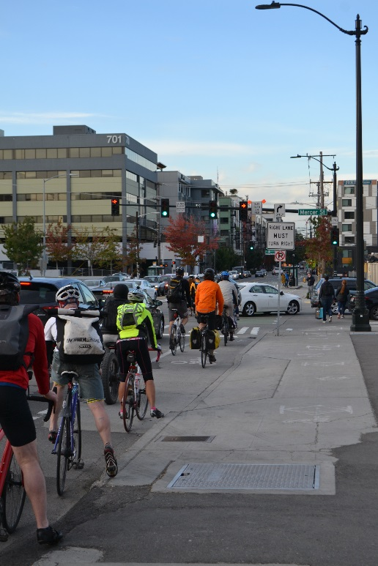 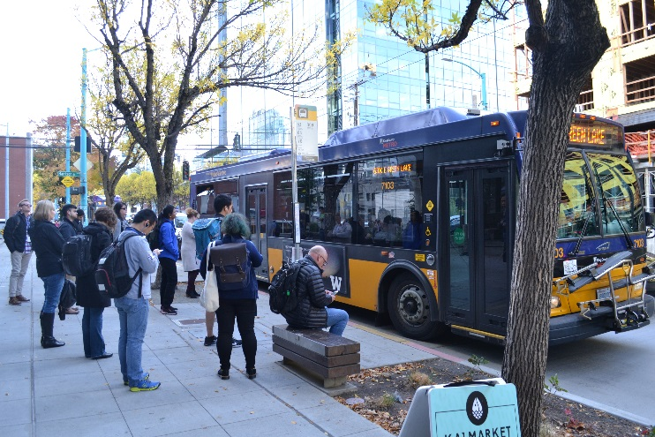 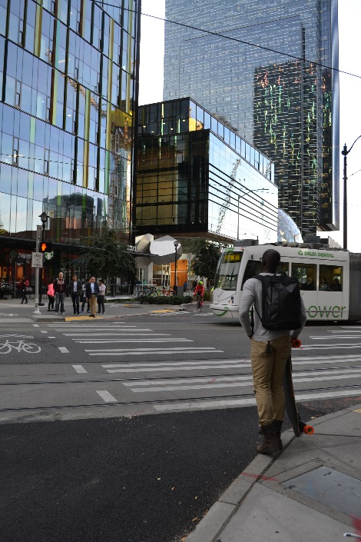

  

As a company with more than 100 full-time employees, EMPLOYER NAME qualifies for Washington State’s Commute Trip Reduction (CTR) Law. The goal of CTR at EMPLOYER NAME is to support commuting options and reduce the number of single occupancy vehicles on our roads, reducing traffic congestion and pollution.

**Facts & Figures**

* Only a small minority of downtown commuters (25%) drive alone to work, down from 35% in 2010.
* Central Puget Sound experienced the highest total increase in transit boardings of any region in the country with 4.7 million new boardings in 2017.
* Walking is the fastest growing commute mode in Seattle. Between 2017 and 2018 there was a 2% increase in walking trips.
* Seattle has the 7th lowest drive-alone rate in the nation and the lowest drive-alone rate of all US cities without a subway system.
* According to the League of American Bicyclists, Washington ranks #1 as most Bicycle Friendly State!
* Seattle ranks 5th in the Nation for “commuter stress index”; choosing an alternative to driving alone can greatly reduce stress.
* In Washington State, more than 50% of CO2 emissions come from vehicles. Choosing alternatives to driving alone really does make a difference!

**Network Mode Split Comparison (email Commute Seattle for stats)**

MODE SPLIT

COMPARISON

EMPLOYER NAME

Citywide

|  |  |  |
| --- | --- | --- |
| **TRANSIT** | **DRIVE ALONE** | **RIDESHARE** |
| **WALK** | **BIKE** | **OTHER** |

Carpool and vanpool are great ways to save money, build community connections, and get to where you need to go!

*Use this space to explain your carpool, vanpool, Zipcar, and/or Car2go program. Encourage employees to find a ridematch or a vanpool at* [*www.rideshareonline.com*](http://www.rideshareonline.com)

*Do you have a discounted or reserved parking for vanpool and/or carpoolers? Do you offer ORCA Business Passport? If so, all agency Vanpool and Vanshare fares are 100% covered by ORCA Passport! Do you offer monthly ORCA cards? If so, King County Metro Vanpools can be purchased through ORCA!*

Commute Options

Transit

When it comes to the Puget Sound transit system, all journeys lead to Seattle! Transit is the #1 option among Seattle commuters going to and through downtown!

*Use this space to explain your transit benefit. Use this space to also explain your Ferry/water Taxi subsidy/program*

*Do you offer ORCA Passes? How much do you subsidize? What is covered with your ORCA card? Do you allow Pre-Tax deductions for Transit passes? Ferry Subsidies? How can employees sign up for this benefit?*

Helpful Commuter Information

* Commute Seattle

[www.commuteseattle.com](http://www.commuteseattle.com)

Online resource for various transportation options.

* King County Metro

metro.kingcounty.gov

Online resource for various transportation options.

* Sound Transit

[www.soundtransit.org](http://www.soundtransit.org)

Sound Transit bus/train schedule and updates.

* Community Transit

[www.communitytransit.org](http://www.communitytransit.org)

Community Transit bus schedule and updates.

* One Bus Away

[www.onebusaway.org](http://www.onebusaway.org)

Real-time bus tracking.

* RideshareOnline

[www.rideshareonline.com](http://www.rideshareonline.com)

Ride matching and calendaring for prizes.

* Mapnificent

[www.mapnificent.net](http://www.mapnificent.net)

Areas reached with public transportation in a given time.

* Walkscore

[www.walkscore.com](http://www.walkscore.com)

Rate your home/workplaces walkability and transit service.

* Washington State Ferries

[www.wsdot.wa.gov/ferries](http://www.wsdot.wa.gov/ferries)

Washington State Ferry schedule and updates.

**Rideshare**

**Biking/Walking**

*Use this space to describe your parking policies.*

*How much do you charge for parking? Are there evening/weekend options? Do you allow a daily payment option for employees to choose driving when they have to and transit when they do not need to drive to work?*

Did you know the Center for Disease Control recommends at least 30 minutes of physical activity per day? Walking or biking to work is a great option for commuting and exercising at the same time.

*Use this space to explain where lockers, showers, bike racks, etc. are located in your office.*

*Do you participate in Bike Month activities in May? Do you offer subsidies to bikers? Are there any local bike shops nearby?*

Contact your Employee Transportation Coordinator:

ENTER ETC CONTACT INFORMATION HERE

**Other**

*Use this space to describe any other alternative commute options your employer offers, including telework/flex scheduling, rides home in case of emergency, or anything else.*

*Let your employees know the best ways to utilize these options and explain the benefits here. Outline some of the advantages of these programs and promote them.*

**Parking**